**Problem 1:** Write a Java program usage of charAt(), concat(), contains(), equals(), and indexOf() functions.

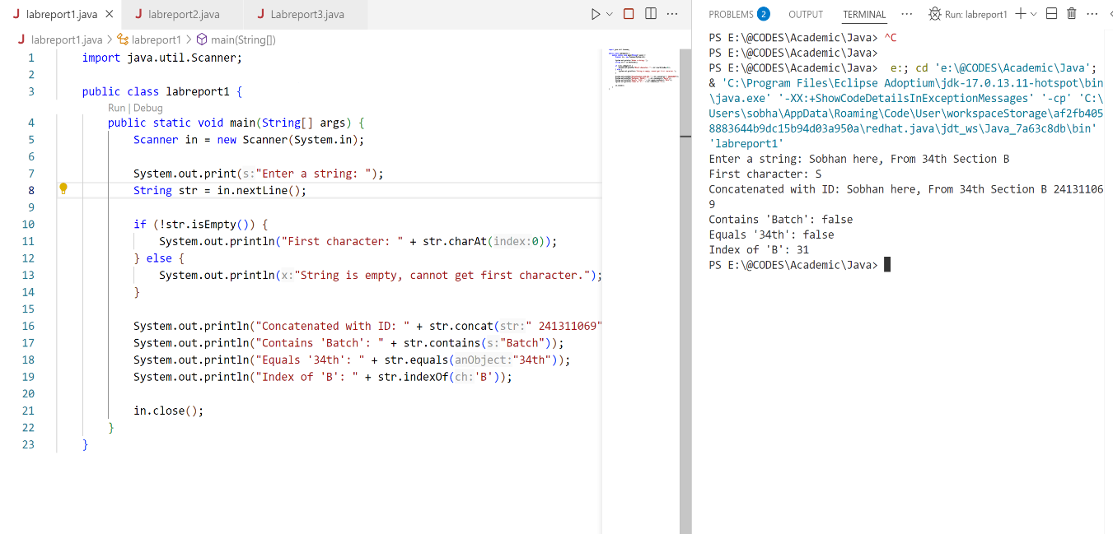

**Problem 2:** Write a Java program usage of isEmpty(), replace(), split(), and trim() functions.

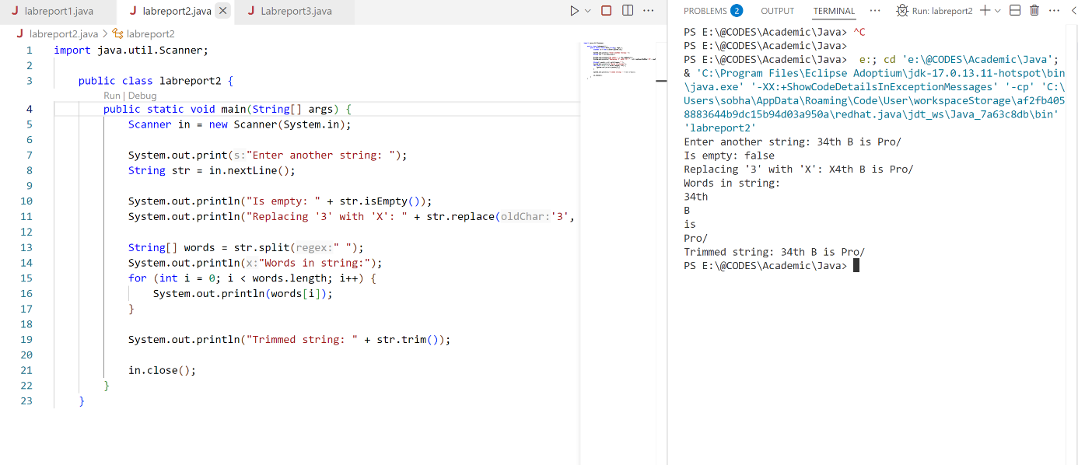

**Problem 3:** Write a Java program to print (1-10) except 5.

